JSON

With XML:  
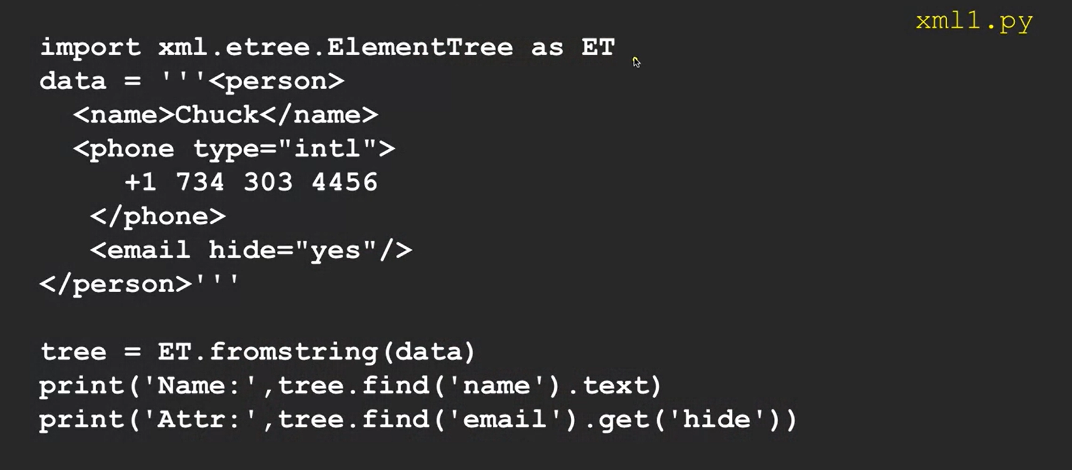  
Same with JSON:

Similarly:  
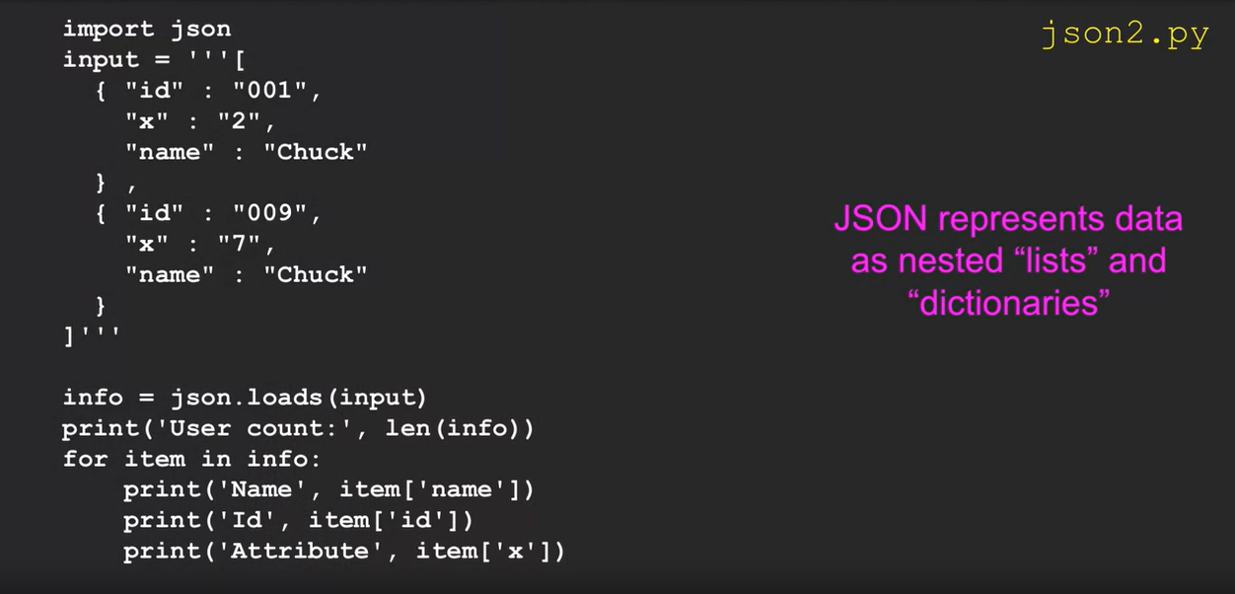

Full Application Code:  
